YUMMY, YUMMY POPCORN
The 4Ps of Marketing

Product Specialist ____________________________________

Place Specialist ____________________________________

Promotion Specialist ____________________________________

Price Specialist ____________________________________

Promotion

PROMOTION DEVELOPMENT

Promotion means advertising. How are you going to get the word out to potential buyers (customers) about your new popcorn? There are many ways to PROMOTE the new product:

- Package – the package for your new popcorn flavor
- Signs – that can be hung from the ceiling in the store
- End cap – arranging product and signs at the end of the aisle
- Billboard – designing a big sign along the freeway
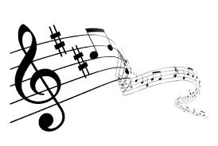
- TV Commercial
- Radio Commercial
- Coupon
- Internet Popup
- Logo – a picture that will help people remember your product
- Slogan – a catchy phrase that will help buyers remember your product
- Jingle – take the slogan and set it to music.

PROMOTION OBJECTIVE

Understand the 4Ps of marketing: Product, Place, Promotion, and Price

PROMOTION ASSIGNMENT

PACKAGE DESIGN
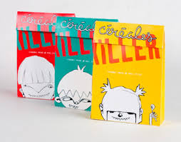
Your team will now design a package for the new popcorn product. It involves looking at the purposes and function of packaging.

Increasing demands for convenience foods has placed greater demands on the requirements of packaging. The following information summarizes the functions of packaging:

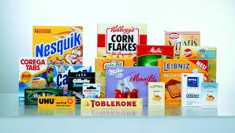
For food in particular, packaging must: protect the food, act as a container to cook the food and transport the food, provide vital information about the contents, and act as a means for display and storage in shops and supermarkets.

Protects Food

Packaging protects food by preserving it and preventing it from spoilage. It forms a barrier against the atmosphere, protecting the food from air, dust, heat, light, moisture and bacteria. It must also transport the product to multiple destinations and thereby be capable of protecting the contents from damage.

Provides Information

Packaging has the fundamental role of conveying information about the product. The packaging has to communicate facts about the name of the food, its weight, ingredients, nutritional information, where and how long to store the food and in what conditions, how the food must be prepared or cooked, the name and address of the company responsible and the country of origin, if applicable.

Many food packages include bar coding. Bar codes let the retailer know how much of the product has been sold so the retailer can order more. It also helps the customer by reducing time spent at the checkout.

Sells Product

Finally, packaging helps sell the product. New products are constantly introduced into the market. This increases the selling functions of packaging design. The packaging is often referred to as “the silent salesman.” At this stage, the packaging design often determines whether the product is purchased.

Materials used for food packaging include:

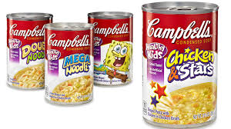
Paper and board – made from wood pulp and recycled paper. Its advantages are that it is light, easy to handle, store, fold and crease. It can be combined with other materials to make laminates and allows for high quality printing.

Plastics – made from oil-based polymers. It is used extensively for packaging foods such as yogurt containers, soft drink bottles, margarine tubs, milk cartons, microwave dinners, etc.

Metals – aluminum and tin plate (sheet steel covered with a thin layer of tin). Metal is used extensively to produce cans, foil containers and foil wrap, metal closures and aerosol spray cans. The advantage is that the canning process preserves food in sterile conditions. As the use of plastics increases, the use of metals for packaging decreases. Developments in metals include producing lighter cans to reduce the excessive use of raw materials.

Glass – another early form of packaging materials. Glass is made from silica or sand, limestone and soda, heated together until they melt and fuse together to form a molten liquid which can be molded. Because glass is impermeable and nonporous, it is often used for carbonated beverages. Glass does not deteriorate, corrode, stain, or fade. It is 100% recyclable, thus reducing environmental waste.

Combinations of materials are frequently used for packaging, such as glass with metal tops, and plastic containers with foil lids and cardboard sleeves.

When considering the packaging for your popcorn, keep in mind the environmental issues, such as the disposal of your package. Think about garbage, garbage collection and recycling. Consider that recycled materials could be used for your package or that your package could be recycled.

- Your team should “brainstorm.” Talk about packaging that you have seen that made an impression on you. It can be food packaging, clothing packaging, electronic packaging, etc. Make a list or draw the packages of products that had memorable packaging here:

- Discuss the colors you should use on the package. Keep in mind that the more colors you use, the more your package will cost. Check with your Price Specialist for the costs. Use the color markers or color pencils to show the colors you will use on the new popcorn package:

- “Being Green” is very important these days. Many customers will buy only products that use a recyclable package. Discuss with your team the purposes of recycling. Write your answers here:

- Discuss with your team what happens to waste that is not recycled? Write your answer here:

- Considering all that you have read and learned about packaging, what materials will your team use for the packaging? Write your answer here:

- Why did your team decide to use this type of material for packaging?

- Use this page to draw your package SHAPE. Give the following dimensions if your package will use one or more of these measurements, then draw the shape below:

  - Height _____________________________

  - Width _____________________________

  - Depth _____________________________

BRAND NAME

General Mills, Nike, and Cabela’s are companies that put their name on their products. This name is called a “Brand.” Brand names can come in many styles. A few include:
Initialism: A name made of initials such, as UPS or IBM
Descriptive: Names that describe a product benefit or function, such as Whole Foods or Toys R' Us
Alliteration and rhyme: Names that are fun to say and stick in the mind, such as Reese's Pieces or Dunkin' Donuts
Evocative: Names that evoke a relevant vivid image, such as Amazon or Crest
Neologisms: Completely made-up words, such as Wii or Häagen-Dazs.
Foreign word: Adoption of a word from another language, such as Volvo or Samsung
Founders' names: Using the names of real people, (especially a founder's name), such as Hewlett-Packard, Dell, Disney, Stussy or Mars
Geography: Many brands are named for regions and landmarks, such as Cisco and Fuji Film
Personification: Many brands take their names from myths, such as Nike; or from the minds of ad execs, such as Betty Crocker
Punny: Some brands create their name by using a silly pun, such as Lord of the Fries, Wok on Water or Eggs Eggscetera

- Your product will need a brand. Choose a style from above and create a brand name for your company. You can draw your brand in the space below:

LOGO

- Logos are pictures that represent brands. It is much easier for people to recognize and remember a logo. Look at the logos below and write the name of the company that the logo represents:
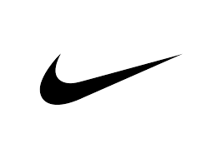
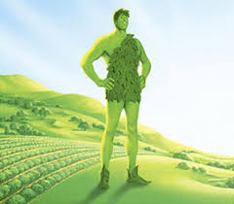

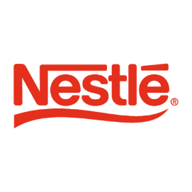

- Design a logo for your brand. The logo is a visual representation of the product or company. In other words, it is a picture that represents your company. Well-established logos give a product a strong corporate identity, so that it can be instantly recognized by the consumer (customer). Design and draw your logo here:

GRAPHIC DESIGN

- Now you will design the graphics for the front of the package. Keep in mind your target market. You will be designing to attract the attention of TEENAGERS so you will want your product to “feel” young, fun, and trendy!

With your team, discuss the use of
- typefaces (font)
- color
- format and balance (how the design fits the front of the package)
- photography and illustration (drawings)

Decide how these methods can be brought together to convey a particular message to meet the project goals.

- Consider the importance of a well-balanced design, informative front of package, and effective labeling (text).
- Include the Brand name and the Logo your team created earlier.

Use this space to create a sketch of the front of your package:

PROMOTIONS & ADVERTISING

You will plan and develop the strategy for advertising and promotion campaigns for the new product. Look at what it takes to be successful in advertising:

MEDIUM/MEDIA

- Electronic – radio, television, Internet
- Print – newspaper, magazine, billboard (includes electronic billboards)

Advertisement must grab the consumer’s attention. To do this, it must be sufficiently different from other advertisements to be noticed and attract the attention of the listener, viewer, or reader. To be a success, the advertisement must communicate to the consumer, the name of the product and its positive attributes.

It must convince the consumer that the product is worth purchasing and entice them to try something new. Most importantly, the advertisement must be memorable so that at the time of purchase the consumer is able to recall the name of the product.

For the advertisement to be successful, it must suit the product that it is trying to sell. For example, a luxury item may be advertised in a sumptuous, sophisticated setting (high-end automobiles) or a new fizzy drink could be portrayed with a young, “up-beat” production style (Coca Cola, Mt. Dew).

The advertisement must be appropriate to the “target market” that it aims to address. In other words, the potential consumers must be able to relate to the advertisement and feel that they have something in common with it.

Advertisements may be presented in a manner to which people aspire. They may portray a “life-style” that people would like for themselves, so by buying the product that is being advertised, they feel as if they are participating in that life-style in a small way. Many advertisements take this approach – from athletic shoes to luxury automobiles.

There are many types of promotions, ranging from special offers; money-off coupons (cut out of newspapers or magazines); direct mail promotions where brochures and information are delivered direct to the home; back-of-the-box offers; and sampling of products sent out by direct mail or in stores and supermarkets. Once the consumer has tasted the product, they may be encouraged to buy it.

- What media will your team use to advertise your new popcorn flavor? Circle 1 in each category.

- Electronic –
  - Radio Commercial
  - Television Commercial

- Print –
  - Newspaper
  - Magazine
  - Billboard (includes electronic billboards)
  - Coupons
  - In-store Signs
  - Internet Popup

- Create a billboard advertisement (print media) here:

END CAPS
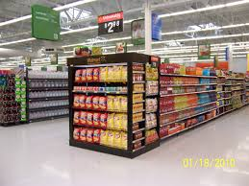
End Cap
End caps are the most valuable real estate of all. An end cap is the area at the end of the aisle. The end caps are areas in the store that customers see first. Product manufacturers also pay large amounts of money to display their product on an End Cap.

- When talking about End Caps, some advertising people say “pile it high and watch it fly.” What do you think this means?

SLOGAN

A slogan is a catchy phrase that sticks in people minds. Slogans are very simple! So simple that, at times, you think you will go nuts because you can’t get it out of your mind.

- “Do the Dew” and “Taste the Rainbow” are examples of slogans. Create a slogan for your new popcorn. Be prepared to teach the slogan to the class when your team gives their oral report to the class.

JINGLE

A jingle is a slogan that has been set to music. As you read the jingles below, be sure to sing them to yourself/team. Complete the jingles by writing on the lines.

- “Like a good neighbor _______________________________________”
- “Nation _________________ is on your side”
- “________________ is the place with the helpful hardware man”
- “In the valley of the Jolly, “HO, ho, ho, _________________________”
- Create a jingle. Be prepared to teach the jingle to the class when your team gives their oral report to the class.

